Student’s name | …………………………………………………….…… | Grade | 4
Subject | Computer | Week No. | 15
Lesson Title | Spreadsheet Formulas | Unit
Worksheet No. ( 15 ) (Answer)

Question A: Write the correct name of each part.

=A1+A2+A3 | Formula Bar
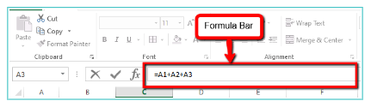
Good Luck

